**Republic of the Philippines**

**CEBU TECHNOLOGICAL UNIVERSITY**

**SAN FRANCISCO CAMPUS**

**San Francisco, Cebu**

 **College of Technology and Engineering**

**DIGITAL ELECTRIC DOOR LOCK  
USING ARDUINO**

Final Project for:

**CT 329: EMBEDDED SYSTEMS**

By:

**Reynan Jude L. Ramos**

**Lovely May T. Orge**

**Efel Jay Calandria**

**Juana May Sampan**

**Jessie Mark Gonzaga**

**INTRODUCTION**

**Project Context**

The lock utilizes modern technologies to provide enhanced security and convenience in residential and commercial applications. The system is based on a microcontroller unit (MCU) and incorporates various components such as a keypad, electric lock mechanism, and an LCD display. The manuscript details the hardware and software aspects of the lock, including the system architecture, circuit design, firmware development, and user interface. Experimental results demonstrate the effectiveness and reliability of the digital electric lock system.

**Purpose and Description of the Project**

The purpose of this project is to design and implement a digital electric lock system using embedded systems technology. The project aims to provide an advanced and secure locking mechanism for residential and commercial applications, enhancing convenience and ensuring reliable access control. The digital electric lock incorporates a keypad for user input, an electric lock mechanism for physical locking/unlocking, and an LCD display for status feedback and user interaction. The system is designed to replace traditional key-based locks and introduce a more efficient and convenient way of securing doors. The user interface of the digital electric lock system focuses on simplicity and ease of use. It includes features such as system initialization, user authentication methods, locking/unlocking operations, and displaying relevant information on the LCD display. The system provides feedback to the user, indicating the status of the lock and any potential errors or security breaches.

**Objectives of the Project**

* Design and develop a digital electric lock system: The primary objective of the project is to design and develop a digital electric lock system using embedded systems technology. This includes selecting appropriate hardware components, designing the circuitry, and implementing the necessary software
* Enhance security and access control: The project aims to create a digital lock system that offers improved security compared to traditional lock mechanisms. The system should incorporate features such as encryption, authentication methods, and tamper detection to prevent unauthorized access and enhance overall access control.
* Identify and address potential vulnerabilities: The project aims to identify and address any potential vulnerabilities or weaknesses in the digital electric lock system. This includes analyzing potential security risks, implementing countermeasures, and ensuring the system can withstand various attack scenarios.
* Document the design and implementation process: It is important to document the entire design and implementation process of the digital electric lock system. This includes detailed documentation of the hardware design, firmware development, software algorithms, and any modifications or improvements made during the project.
* Provide recommendations for future enhancements: Based on the findings and lessons learned from the project, the objective is to provide recommendations for future enhancements or further research. This may include suggestions for improving security features, optimizing user experience, or exploring additional functionalities.

**TECHNICALITY OF THE PROJECT**

**Technicality of the Project**

Digital electric lock using Arduino, a system equipped with solenoid lock which will be the output of the system. Supported with four by three (4x3) which will be the input that will determine if the lock will be off if the password given was right.

**Details of the technologies to be used**

The project involves utilizing several technologies to design and implement the digital electric lock system. The specific technologies to be used include:

1. Embedded Systems: The project revolves around embedded systems technology, which involves designing and developing systems with dedicated computing capabilities. The digital electric lock system will be based on an embedded system architecture, utilizing a microcontroller unit (MCU) as the core component.
2. Microcontroller Unit (MCU): An MCU will be selected based on the system requirements. Arduino UNO was used in this model. The MCU will provide the processing power, memory, and input/output capabilities necessary for controlling the digital electric lock system.
3. Keypad: A keypad will be used to enable user input for locking and unlocking the system. The keypad can be a matrix-based membrane keypad or a capacitive touch keypad, depending on the project requirements and design preferences.
4. Electric Lock Mechanism: The electric lock mechanism will be employed to physically lock and unlock the door. Various types of electric locks are available, including electromagnetic locks, solenoid locks, or motor-driven locks. The selection of the electric lock mechanism will depend on factors such as security requirements, power consumption, and physical compatibility with the door.
5. LCD Display: An LCD (Liquid Crystal Display) module will be integrated into the system to provide visual feedback and status information. The display can be alphanumeric or graphical, depending on the desired level of information and user interaction. The LCD display will be controlled by the MCU, allowing it to show relevant messages and system status updates.

**How the project will work**

The project will ask a 4 digit code which will determine if the lock will be open or not. If the 4 digit pin code is correct the lock will open, and if not the lock will stay closed.

**Circuit Diagram of the Project**

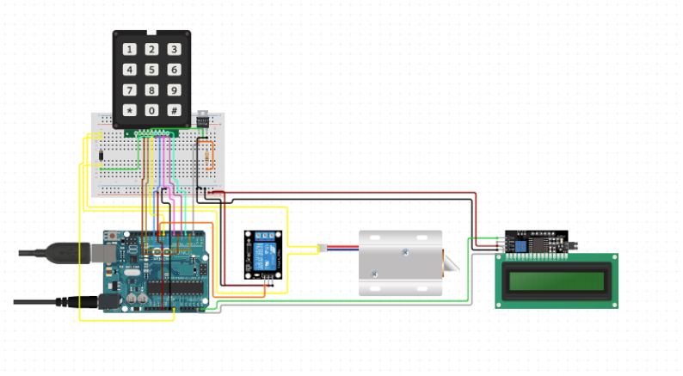

**METHODOLOGY**

**DATA PROCESS AND MODELING**

**Context Diagram**

+-------------------+

| Digital Electric |

| Lock |

+-------------------+

|

|

|

|

+-------+--------+

| |

+------+ User Interface |

| | |

| +----------------+

|

|

+-----+------+

| |

| Electric |

| Lock |

| Mechanism |

| |

+-----+------+

|

|

+-----+------+

| |

| Keypad |

| |

+------------+

**In the above context diagram:**

* The "Digital Electric Lock" represents the main system.
* The "User Interface" represents the user interaction component, which includes the keypad for input and an LCD display for feedback.
* The "Electric Lock Mechanism" represents the physical lock mechanism that is controlled by the system to secure or release the lock.
* The "Keypad" represents the input device through which the user interacts with the system.

**System Flowchart**

**INITIALIZE SYSTEM**

**START**

**END**

**PERFORM LOCK/UNLOCK OPERATION**

**CHECK FOR SYSTEM TERMINATION**

**PROCESS USER INPUT**

**UPDATE LCD DISPLAY**

**VALIDATE USER INPUT**

**WAIT FOR USER INPUT**

**INSTALLATION PROCESS**

**Materials needed:**

* **12v Solenoid Lock**
* **12v DC battery**
* **5v Relay**
* **4x3 Keypad**
* **Arduino Uno**
* **Liquid Crystal Display (LCD)**
* **Jumping Wires**

**For the Casing:**

* **5 plywood and 1 plyboard**
* **Screws**
* **Screwdriver**
* **Paint**
* **Bottle cap**

**Step 1: Hardware Setup**

1. Connect the 7 pin 4x3 keypad to the arduino board from digital pin to 6 – 13.
2. Connect the LCD to the arduino board, GND to GND port, VCC to 5v port, SDA and SCL to A04 and A05 port of the board
3. Get your 12v Dc charger and split the cord, the red wire will go to the Normally Closed screw and the red wire of the Solenoid lock will go to the Common screw. And now, you will emerge the Black wire of the battery and the blue wire of the solenoid lock.
4. Now, look at your relay and insert a wire in the GND and put it in another GND port. Insert a wire in the VCC and put it in the 3v port of the board. Finally insert a wire in the signal and put it on the Digital pin 4.

**Step 2: Software Setup**

1. Install an Arduino IDE in your Computer, Laptop or CP.
2. After the instalment Plug a USB into your arduino and connect it into your device.
3. Install certain libraries for keypad and the LCD in order to detect the certain devices.
4. After that Save and Upload your Code.
5. Test it.

**Documentary:**

